A SUSPICIOUS FINANCIAL TRANSACTION DETECTION MODEL USING AUTOENCODER AND RISK-BASED APPROACH

Abstract: Thisstudyfocuses on the detection of suspicious transactions characterized by the opaque and complex electronic channels that have emerged with the advancement of electronic financial technology. Amodelthatcanimmediatelyreflecttrendsinvarioustypesoffundandtransactionflows,andautonomously learn complex transaction types, is proposed. As a key outcome, an internal control model for detecting suspicious transactions based on the risk-based approach is constructed by utilizing autoencoder to enhance anti-money laundering (AML) operations, and this method surpasses traditional AML methods. Additionally, the proposed model facilitates the extraction of candidate factors for suspicious transactions and updates warning models in AML monitoring systems, thereby allowing for the analysis of alert cases. As a result, AML operations based on the proposed model are quantitatively and qualitatively superior to those based on the traditional approaches, resulting in swift processing by avoiding exhaustive examinations of suspicious transaction types. This research provides information that can improve the AML operation systems used within the financial sector by evaluating the risk of suspicious transactions and reflecting various elements of funds and transactions.

INDEX TERMS Risk-based approach (RBA), anti money laundering (AML), autoencoder, money laundering symptoms, suspicious transaction report (STR)

INTRODUCTION

Financial institutions today face increasing challenges in identifying suspicious financial transactions due to the rapid growth of digital payments, online banking, and real-time money transfers. Traditional rule-based systems often struggle to detect complex and evolving fraud patterns, leading to higher false alarms and missed anomalies. To address these limitations, advanced machine learning-based solutions have gained tremendous importance in recent years. This study presents a suspicious financial transaction detection model that combines the power of autoencoder-based anomaly detection with a comprehensive risk-based assessment approach. Autoencoders, being unsupervised deep learning models, learn normal transaction behavior and effectively identify unusual patterns that deviate from normality. By incorporating a risk-based framework, the model assigns weighted scores to various risk factors such as transaction amount, frequency, customer profile, geolocation, and historical behavior. This integrated approach enhances detection accuracy by analyzing both feature-level anomalies and user-level risk indicators. The proposed method provides a scalable and adaptive solution capable of handling large volumes of data in real time. Moreover, it reduces dependency on labeled datasets, which are often scarce in financial fraud scenarios. The system supports proactive monitoring and early threat identification, helping financial institutions comply with regulatory requirements such as AML and KYC guidelines. By leveraging deep learning and risk intelligence, the model strengthens organizational security and minimizes economic losses. Overall, this work contributes a robust, intelligent, and data-driven framework to detect suspicious financial activities with higher precision and reduced false positives.

Literature Review
- Surveys of anomaly/fraud detection summarize that unsupervised and semi-supervised methods (including autoencoders) outperform classical rules in catching evolving fraud patterns and reduce manual rule-tuning overhead. ScienceDirect
- Early and widely-cited work shows autoencoders learn compact representations of “normal” transaction behavior and use reconstruction error to flag anomalies, making them especially useful when labeled fraud samples are scarce. ACM Digital Library+1
- Variational autoencoders (VAEs) and denoising/robust variants have been proposed to improve detection stability and explainability by modeling uncertainty and resisting noisy/imbalanced financial data. CEUR Workshop Proceedings+1
- Hybrid pipelines that combine autoencoder feature extraction with gradient-boosted decision trees (e.g., LightGBM) or probabilistic classifiers achieve higher recall and precision than either approach alone on credit-card datasets. MDPI+1
- Recent work uses generative models (GANs, VAE+GAN) to augment normal transaction distributions and better separate subtle fraudulent modes — useful for scarce fraud labels and synthetic scenario testing. arXiv+1
- Several domain studies demonstrate practical deployments of autoencoder-based detectors in banking and e-payments, noting gains in scalability but warning that reconstruction thresholds must be tuned per customer segment to avoid high false positives. ijemh.com+1
- The risk-based approach (RBA) in AML literature complements anomaly scoring by combining transaction-level anomalies with customer/profile risk indicators, enabling prioritization and regulatory alignment (KYC/AML). assets.adgm.com+1
- Integrative systems that merge unsupervised anomaly scores (from autoencoders) with rule-based risk scores or business rules produce better investigative triage — reducing analyst workload by ranking alerts by severity. ijsred.com+1
- Comparative studies and benchmarks stress handling class imbalance, concept drift, and realtime streaming as the main engineering challenges; proposed remedies include continual learning, threshold adaptation, and feedback loops from investigator outcomes. arno.uvt.nl+1
- Very recent papers (2023–2025) propose enhanced autoencoder architectures (convolutional, probabilistic, ensemble) and documented case studies showing that combining deep anomaly detectors with explicit RBA scoring yields measurable reductions in false positives and better AML coverage. AASMR+2ijcnis.org+2

- REQUIREMENT

➢ H/W System Configuration:-
➢ RAM - 4 GB (min)
➢ Key Board - Standard Windows Keyboard
➢ Mouse - Two or Three Button Mouse
➢ Monitor - SVGA

SOFTWARE REQUIREMENTS:
- Operating system : Windows
- Coding Language : Python.
- Back-End : Python.
- front-End : html,css
- Designing : Html, css
- Application : django

EXISTING SYSTEM
The existing systems used in financial institutions to detect suspicious or fraudulent transactions primarily rely on rule-based mechanisms and supervised machine learning models. Rule-based systems operate on predefined thresholds, business rules, and expert-defined patterns such as unusual transaction amounts, high-risk locations, rapid transfers, or violated KYC conditions. Although these systems are easy to implement, they are highly rigid and fail to detect new, emerging, or sophisticated fraud patterns. They also generate a significant number of false positives, burdening analysts with unnecessary alerts. Supervised machine learning approaches, such as decision trees, logistic regression, and random forests, improve accuracy but depend heavily on large labeled datasets, which are extremely rare in real-life financial environments because fraud cases represent less than 1% of total transactions. These models also suffer from class imbalance, concept drift, and an inability to detect unknown anomaly patterns. Existing AML (Anti-Money Laundering) solutions incorporate basic risk scoring based on customer profile and transaction metadata, but these tools function independently from anomaly detection systems, leading to fragmented insights and inconsistent alert prioritization. Overall, current systems lack adaptability, scalability, and intelligent integration between anomaly detection and risk-based evaluation, making them insufficient for modern, dynamic digital financial ecosystems.

PROPOSED SYSTEM
The proposed system introduces an intelligent and automated suspicious financial transaction detection platform built using Django as the user interface and multiple machine-learning models for backend analysis. The system allows users to upload transaction datasets, automatically preprocesses them by removing missing values, eliminating duplicates, and encoding categorical features to ensure clean and consistent input. The core detection mechanism uses multiple classification algorithms, including Decision Tree, Deep Neural Network (DNN/MLP), and Support Vector Machine, which are trained on the processed dataset to learn normal and fraudulent transaction patterns. The system splits the dataset into training and testing sets to evaluate model performance and stores trained models for future predictions. Each algorithm’s performance is measured using accuracy, precision, recall, F1-score, and confusion matrix visualizations, giving clear insights into their effectiveness. The system also generates performance summaries with bar charts and pie charts to help users compare metrics across algorithms. Once trained, the system supports real-time batch prediction by allowing users to upload new transaction files, which the trained models classify as “Normal” or “Fraud.” The platform’s modular design ensures easy model updates, scalable deployment, and efficient data handling. Overall, the proposed system provides a user-friendly, secure, and data-driven framework for detecting suspicious financial activities with improved accuracy and reliability.

SYSTEM STUDY
FEASIBILITY STUDY
The feasibility of the project is analyzed in this phase and business proposal is put forth with a very general plan for the project and some cost estimates. During system analysis the feasibility study of the proposed system is to be carried out. This is to ensure that the proposed system is not a burden to the company. For feasibility analysis, some understanding of the major requirements for the system is essential.
Three key considerations involved in the feasibility analysis are
- ECONOMICAL FEASIBILITY
- TECHNICAL FEASIBILITY
- SOCIAL FEASIBILITY

ECONOMICAL FEASIBILITY
This study is carried out to check the economic impact that the system will have on the organization. The amount of fund that the company can pour into the research and development of the system is limited. The expenditures must be justified. Thus the developed system as well within the budget and this was achieved because most of the technologies used are freely available. Only the customized products had to be purchased.

TECHNICAL FEASIBILITY
This study is carried out to check the technical feasibility, that is, the technical requirements of the system. Any system developed must not have a high demand on the available technical resources. This will lead to high demands on the available technical resources. This will lead to high demands being placed on the client. The developed system must have a modest requirement, as only minimal or null changes are required for implementing this system.

SOCIAL FEASIBILITY
The aspect of study is to check the level of acceptance of the system by the user. This includes the process of training the user to use the system efficiently. The user must not feel threatened by the system, instead must accept it as a necessity. The level of acceptance by the users solely depends on the methods that are employed to educate the user about the system and to make him familiar with it. His level of confidence must be raised so that he is also able to make some constructive criticism, which is welcomed, as he is the final user of the system.

SYSTEM DESIGN
UML DIAGRAMS
UML stands for Unified Modeling Language. UML is a standardized general-purpose modeling language in the field of object-oriented software engineering. The standard is managed, and was created by, the Object Management Group. The goal is for UML to become a common language for creating models of object-oriented computer software. In its current form UML is comprised of two major components: a Meta-model and a notation. In the future, some form of method or process may also be added to; or associated with, UML.
The Unified Modeling Language is a standard language for specifying, Visualization, Constructing and documenting the artifacts of software system, as well as for business modeling and other non-software systems. The UML represents a collection of best engineering practices that have proven successful in the modeling of large and complex systems. The UML is a very important part of developing objects-oriented software and the software development process. The UML uses mostly graphical notations to express the design of software projects.
GOALS: The Primary goals in the design of the UML are as follows:
- Provide users a ready-to-use, expressive visual modeling Language so that they can develop and exchange meaningful models.
- Provide extendibility and specialization mechanisms to extend the core concepts.
- Be independent of particular programming languages and development process.
- Provide a formal basis for understanding the modeling language.
- Encourage the growth of OO tools market.
- Support higher level development concepts such as collaborations, frameworks, patterns and components.
- Integrate best practices.

Use case diagram:
A use case diagram in the Unified Modeling Language (UML) is a type of behavioral diagram defined by and created from a Use-case analysis. Its purpose is to present a graphical overview of the functionality provided by a system in terms of actors, their goals (represented as use cases), and any dependencies between those use cases. The main purpose of a use case diagram is to show what system functions are performed for which actor. Roles of the actors in the system can be depicted.

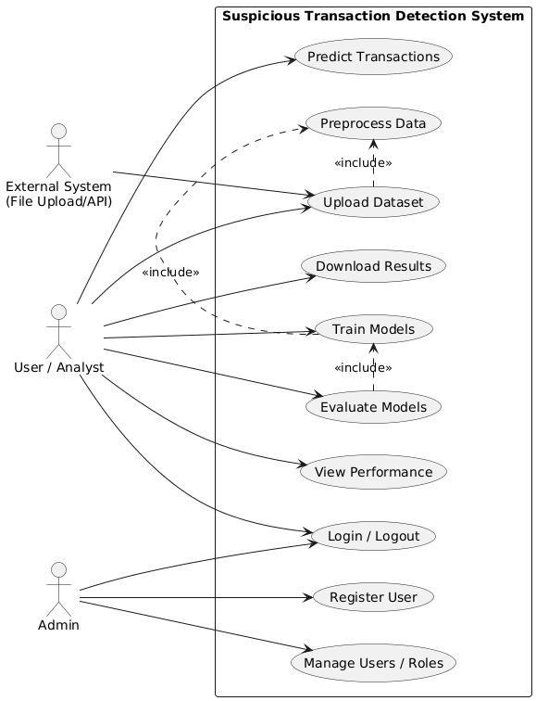

CLASS DIAGRAM

The class diagram is used to refine the use case diagram and define a detailed design of the system. The class diagram classifies the actors defined in the use case diagram into a set of interrelated classes. The relationship or association between the classes can be either an "is-a" or "has-a" relationship. Each class in the class diagram was capable of providing certain functionalities. These functionalities provided by the class are termed "methods" of the class. Apart from this, each class may have certain "attributes" that uniquely identify the class.

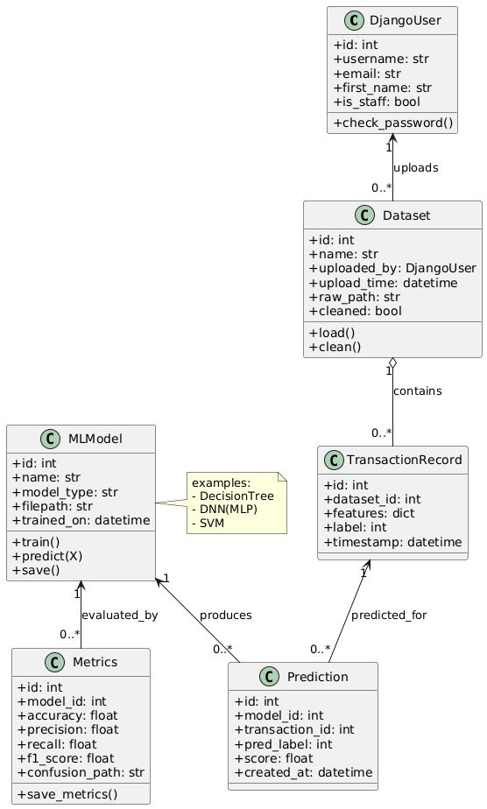

Sequence Diagram

A sequence diagram in Unified Modeling Language (UML) is a kind of interaction diagram that shows how processes operate with one another and in what order. It is a construct of a Message Sequence Chart. A sequence diagram shows, as parallel vertical lines (“lifelines”), different processes or objects that live simultaneously, and as horizontal arrows, the messages exchanged between them, in the order in which they occur. This allows the specification of simple runtime scenarios in a graphical manner.

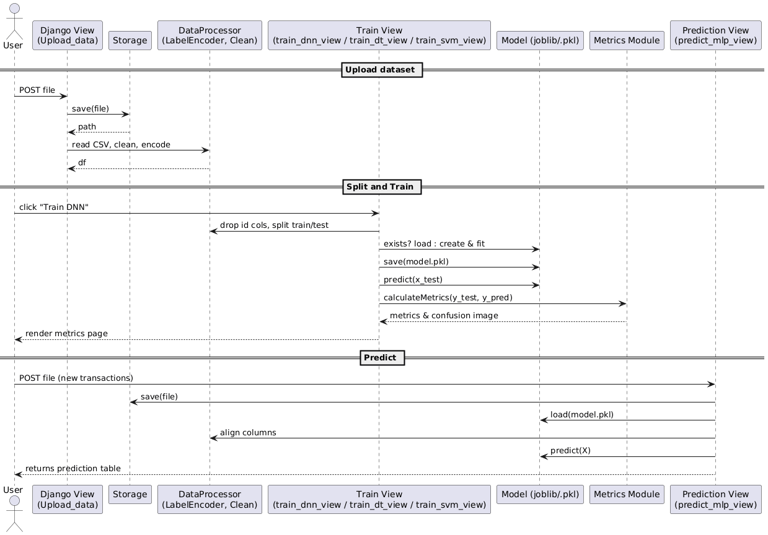

Activity Diagram

\Activity diagrams are graphical representations of Workflows of stepwise activities and actions with support for choice, iteration, and concurrency. In the Unified Modeling Language, activity diagrams can be used to describe the business and operational step-by-step workflows of components in a system. An activity diagram shows the overall flow of control.

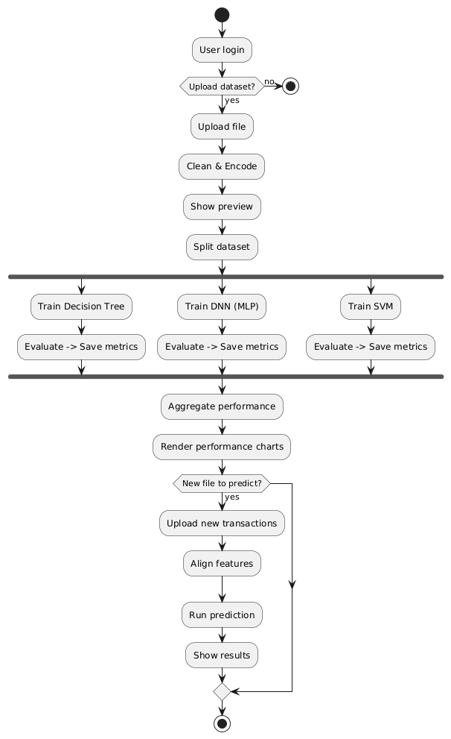

ER Diagram
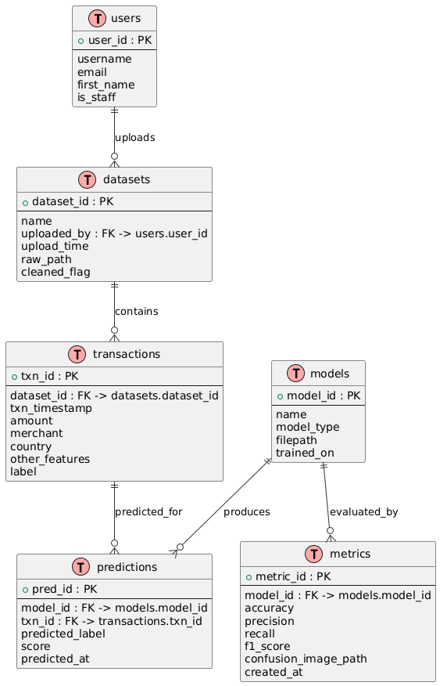

ALGORITHMS
The proposed suspicious financial transaction detection system employs multiple machine-learning algorithms to learn transaction patterns and classify records as Normal or Fraud. Each algorithm utilizes different learning mechanisms, enabling a comparative evaluation of accuracy, precision, recall, and F1-score. Using diverse algorithms helps improve overall model robustness and ensures that complex fraud patterns are captured effectively.
1. Decision Tree Classifier (DT)
The Decision Tree algorithm is a supervised classification method that builds a hierarchical model by splitting data based on feature values. At each node, the algorithm selects the feature that provides the highest information gain or lowest Gini impurity. The tree continues expanding until all records are classified or a stopping criterion is reached. Decision Trees are interpretable, easy to visualize, and effective for datasets containing a mix of categorical and numerical features. In financial fraud detection, they help identify rule-like patterns where specific combinations of transaction features indicate suspicious behavior.
2. Deep Neural Network (DNN / MLP Classifier)
The system uses a Multi-Layer Perceptron (MLP)-based Deep Neural Network consisting of input, hidden, and output layers. Each neuron applies weighted sums and non-linear activation functions to learn complex relationships between features. The DNN can detect highly non-linear and hidden patterns in transaction data that may not be evident through traditional models. Training is performed using backpropagation, minimizing error through iterative weight adjustments. This makes DNNs particularly effective in capturing subtle fraud signals and multi-feature dependencies.
3. Support Vector Machine (SVM)
SVM is a powerful supervised classifier that finds the optimal hyperplane to separate classes with the maximum margin. For non-linearly separable data, the radial basis function (RBF) kernel is applied to project the data into a high-dimensional space where separation becomes easier. SVM is highly effective in fraud detection due to its ability to handle high dimensionality and detect borderline cases where fraudulent transactions closely resemble normal behavior.
4. Label Encoding for Categorical Features
Since machine-learning algorithms require numeric inputs, the system uses LabelEncoder to convert categorical columns (such as merchant type, country, or transaction mode) into corresponding integers. This preprocessing step ensures compatibility with all classification models.
5. Evaluation Metrics Algorithm
The system computes key metrics such as Accuracy, Precision, Recall, and F1-Score. These metrics are essential to evaluate how well the models detect fraudulent transactions while minimizing false positives and false negatives. The confusion matrix is also generated to visualize model performance across classes.
6. Prediction Algorithm
Trained models are stored and later loaded to classify new, unseen transaction records. Feature alignment ensures that test datasets match training dataset structure, and predictions are assigned as Normal or Fraud using the model output.

MODULES
The proposed suspicious financial transaction detection system is divided into several interconnected modules, each responsible for a specific stage of data processing, model training, evaluation, and prediction. These modules work together to ensure efficient detection of fraudulent transactions and provide a seamless experience for users.

1. User Authentication Module
This module handles user registration, login, and logout using Django’s built-in authentication system. It ensures secure access to the application and prevents unauthorized users from performing sensitive operations such as training models or uploading datasets. The system validates user credentials, manages sessions, and controls access to different functionalities.

2. Dataset Upload and Preprocessing Module
Users upload transaction datasets in CSV format through this module. The system reads the file, removes missing values, eliminates duplicate records, and applies Label Encoding to convert categorical data into numerical form. This module ensures that the dataset is clean, consistent, and suitable for machine-learning training.

3. Data Splitting Module
This module divides the cleaned dataset into training and testing sets using an 80:20 ratio. Features (X) and labels (y) are separated to create input variables for model training. Splitting ensures that models are evaluated on unseen data, improving reliability and reducing overfitting.

4. Machine Learning Model Training Module
This module trains multiple classification algorithms:
- Decision Tree Classifier
- Deep Neural Network (DNN / MLP Classifier)
- Support Vector Machine (SVM)
Each model learns transaction patterns from training data and stores the trained model files (.pkl). Non-numeric ID fields are automatically removed to prevent errors during training.

5. Model Evaluation & Metrics Module
The evaluation module computes key performance metrics including Accuracy, Precision, Recall, and F1-Score. A confusion matrix is generated for each model using Seaborn heatmaps and saved as an image. These metrics help users understand which model performs best for fraud detection.

6. Performance Summary & Visualization Module
This module aggregates all model metrics into a single table and generates bar charts and pie charts to visually compare model performance. Users can easily identify the most accurate and reliable algorithm based on graphical reports.
7. Prediction Module
Users can upload new transaction datasets for prediction. The system loads the trained DNN/MLP model, aligns feature columns, performs classification, and outputs predicted labels such as “Normal” or “Fraud.” The resulting predictions are displayed in a structured table format.

8. File Management & Storage Module
This module manages temporary storage of uploaded CSV files, confusion matrix images, and trained model files. It ensures efficient handling of file paths and automatic cleanup after processing.

System Environment:

What is Python :-
Below are some facts about Python.
Python is currently the most widely used multi-purpose, high-level programming language.
Python allows programming in Object-Oriented and Procedural paradigms. Python programs generally are smaller than other programming languages like Java.
Programmers have to type relatively less and indentation requirement of the language, makes them readable all the time.
Python language is being used by almost all tech-giant companies like – Google, Amazon, Facebook, Instagram, Dropbox, Uber… etc.
The biggest strength of Python is huge collection of standard library which can be used for the following .
  - Machine Learning
  - GUI Applications (like Kivy, Tkinter, PyQt etc. )
  - Web frameworks like Django (used by YouTube, Instagram, Dropbox)
  - Image processing (like Opencv, Pillow)
  - Web scraping (like Scrapy, BeautifulSoup, Selenium)
  - Test frameworks
  - Multimedia

Advantages of Python :-
Let’s see how Python dominates over other languages.

1. Extensive Libraries
Python downloads with an extensive library and it contain code for various purposes like regular expressions, documentation-generation, unit-testing, web browsers, threading, databases, CGI, email, image manipulation, and more. So, we don’t have to write the complete code for that manually.

2. Extensible
As we have seen earlier, Python can be extended to other languages. You can write some of your code in languages like C++ or C. This comes in handy, especially in projects.

3. Embeddable
Complimentary to extensibility, Python is embeddable as well. You can put your Python code in your source code of a different language, like C++. This lets us add scripting capabilities to our code in the other language.

4. Improved Productivity
The language’s simplicity and extensive libraries render programmers more productive than languages like Java and C++ do. Also, the fact that you need to write less and get more things done.

5. IOT Opportunities
Since Python forms the basis of new platforms like Raspberry Pi, it finds the future bright for the Internet Of Things. This is a way to connect the language with the real world.

6. Simple and Easy
When working with Java, you may have to create a class to print ‘Hello World’. But in Python, just a print statement will do. It is also quite easy to learn, understand, and code. This is why when people pick up Python, they have a hard time adjusting to other more verbose languages like Java.

7. Readable
Because it is not such a verbose language, reading Python is much like reading English. This is the reason why it is so easy to learn, understand, and code. It also does not need curly braces to define blocks, and indentation is mandatory. This further aids the readability of the code.

8. Object-Oriented
This language supports both the procedural and object-oriented programming paradigms. While functions help us with code reusability, classes and objects let us model the real world. A class allows the encapsulation of data and functions into one.

9. Free and Open-Source
Like we said earlier, Python is freely available. But not only can you download Python for free, but you can also download its source code, make changes to it, and even distribute it. It downloads with an extensive collection of libraries to help you with your tasks.

10. Portable
When you code your project in a language like C++, you may need to make some changes to it if you want to run it on another platform. But it isn’t the same with Python. Here, you need to code only once, and you can run it anywhere. This is called Write Once Run Anywhere (WORA). However, you need to be careful enough not to include any system-dependent features.

11. Interpreted
Lastly, we will say that it is an interpreted language. Since statements are executed one by one, debugging is easier than in compiled languages.
Any doubts till now in the advantages of Python? Mention in the comment section.

Advantages of Python Over Other Languages

1. Less Coding
Almost all of the tasks done in Python requires less coding when the same task is done in other languages. Python also has an awesome standard library support, so you don’t have to search for any third-party libraries to get your job done. This is the reason that many people suggest learning Python to beginners.

2. Affordable
Python is free therefore individuals, small companies or big organizations can leverage the free available resources to build applications. Python is popular and widely used so it gives you better community support.
The 2019 Github annual survey showed us that Python has overtaken Java in the most popular programming language category.

3. Python is for Everyone
Python code can run on any machine whether it is Linux, Mac or Windows. Programmers need to learn different languages for different jobs but with Python, you can professionally build web apps, perform data analysis and machine learning, automate things, do web scraping and also build games and powerful visualizations. It is an all-rounder programming language.

Disadvantages of Python
So far, we’ve seen why Python is a great choice for your project. But if you choose it, you should be aware of its consequences as well. Let’s now see the downsides of choosing Python over another language.

1. Speed Limitations
We have seen that Python code is executed line by line. But since Python is interpreted, it often results in slow execution. This, however, isn’t a problem unless speed is a focal point for the project. In other words, unless high speed is a requirement, the benefits offered by Python are enough to distract us from its speed limitations.

2. Weak in Mobile Computing and Browsers
While it serves as an excellent server-side language, Python is much rarely seen on the client-side. Besides that, it is rarely ever used to implement smartphone-based applications. One such application is called Carbonnelle.
The reason it is not so famous despite the existence of Brython is that it isn’t that secure.

3. Design Restrictions
As you know, Python is dynamically-typed. This means that you don’t need to declare the type of variable while writing the code. It uses duck-typing. But wait, what’s that? Well, it just means that if it looks like a duck, it must be a duck. While this is easy on the programmers during coding, it can raise run-time errors.

4. Underdeveloped Database Access Layers
Compared to more widely used technologies like JDBC (Java DataBase Connectivity) and ODBC (Open DataBase Connectivity), Python’s database access layers are a bit underdeveloped. Consequently, it is less often applied in huge enterprises.

5. Simple
No, we’re not kidding. Python’s simplicity can indeed be a problem. Take my example. I don’t do Java, I’m more of a Python person. To me, its syntax is so simple that the verbosity of Java code seems unnecessary.
This was all about the Advantages and Disadvantages of Python Programming Language.
History of Python : -

What do the alphabet and the programming language Python have in common? Right, both start with ABC. If we are talking about ABC in the Python context, it's clear that the programming language ABC is meant. ABC is a general-purpose programming language and programming environment, which had been developed in the Netherlands, Amsterdam, at the CWI (Centrum Wiskunde &Informatica). The greatest achievement of ABC was to influence the design of Python.Python was conceptualized in the late 1980s. Guido van Rossum worked that time in a project at the CWI, called Amoeba, a distributed operating system. In an interview with Bill Venners¹, Guido van Rossum said: "In the early 1980s, I worked as an implementer on a team building a language called ABC at Centrum voor Wiskunde en Informatica (CWI).
I don't know how well people know ABC's influence on Python. I try to mention ABC's influence because I'm indebted to everything I learned during that project and to the people who worked on it."Later on in the same Interview, Guido van Rossum continued: "I remembered all my experience and some of my frustration with ABC. I decided to try to design a simple scripting language that possessed some of ABC's better properties, but without its problems. So I started typing. I created a simple virtual machine, a simple parser, and a simple runtime. I made my own version of the various ABC parts that I liked. I created a basic syntax, used indentation for statement grouping instead of curly braces or begin-end blocks, and developed a small number of powerful data types: a hash table (or dictionary, as we call it), a list, strings, and numbers."

Introduction to Machine Learning
Machine Learning (ML) is a branch of artificial intelligence (AI) that enables computers to learn from data and improve their performance on tasks without being explicitly programmed. Unlike traditional programming, where rules and logic are manually coded, ML algorithms identify patterns, relationships, and trends within datasets, allowing systems to make predictions or decisions based on new data. This capability has transformed numerous industries, from healthcare and finance to retail and transportation, by enabling automation, personalization, and predictive analytics.
Types of Machine Learning
Machine learning is broadly categorized into three types: supervised learning, unsupervised learning, and reinforcement learning. Supervised learning involves training algorithms on labeled datasets, where the input and expected output are known, enabling the model to predict outcomes for new data. Common applications include spam detection, loan approval, and disease prediction. Unsupervised learning, on the other hand, deals with unlabeled data and focuses on finding hidden patterns or groupings, such as customer segmentation or anomaly detection. Reinforcement learning is based on trial and error, where an agent learns to make sequential decisions by receiving feedback from its environment, commonly used in robotics, gaming, and autonomous systems.
Applications and Impact
Machine learning is widely applied across diverse fields. In healthcare, ML predicts disease progression, assists in medical imaging analysis, and recommends personalized treatments. In finance, it detects fraudulent transactions and predicts market trends. E-commerce platforms leverage ML for recommendation systems and demand forecasting. Additionally, ML plays a crucial role in natural language processing, powering chatbots, translation services, and voice assistants. Its ability to analyze vast amounts of data efficiently makes it indispensable in modern technology-driven solutions.
Challenges and Future Directions
Despite its benefits, machine learning faces challenges such as data quality, bias, interpretability, and computational costs. Poor-quality or unbalanced datasets can lead to inaccurate predictions, while algorithmic bias can reinforce societal inequalities. Research is ongoing to develop explainable AI models, improve training efficiency, and integrate ethical considerations. The future of machine learning involves combining it with edge computing, IoT, and reinforcement learning to create smarter, autonomous, and context-aware systems capable of adapting to complex real-world environments.
What is Machine Learning : -
Before we take a look at the details of various machine learning methods, let's start by looking at what machine learning is, and what it isn't. Machine learning is often categorized as a subfield of artificial intelligence, but I find that categorization can often be misleading at first brush. The study of machine learning certainly arose from research in this context, but in the data science application of machine learning methods, it's more helpful to think of machine learning as a means of building models of data.
Fundamentally, machine learning involves building mathematical models to help understand data. "Learning" enters the fray when we give these models tunable parameters that can be adapted to observed data; in this way the program can be considered to be "learning" from the data.
Once these models have been fit to previously seen data, they can be used to predict and understand aspects of newly observed data. I'll leave to the reader the more philosophical digression regarding the extent to which this type of mathematical, model-based "learning" is similar to the "learning" exhibited by the human brain.Understanding the problem setting in machine learning is essential to using these tools effectively, and so we will start with some broad categorizations of the types of approaches we'll discuss here.
Categories Of Machine Leaning :-
At the most fundamental level, machine learning can be categorized into two main types: supervised learning and unsupervised learning.
Supervised learning involves somehow modeling the relationship between measured features of data and some label associated with the data; once this model is determined, it can be used to apply labels to new, unknown data. This is further subdivided into classification tasks and regression tasks: in classification, the labels are discrete categories, while in regression, the labels are continuous quantities. We will see examples of both types of supervised learning in the following section.

Unsupervised learning involves modeling the features of a dataset without reference to any label, and is often described as "letting the dataset speak for itself." These models include tasks such as clustering and dimensionality reduction.
Clustering algorithms identify distinct groups of data, while dimensionality reduction algorithms search for more succinct representations of the data. We will see examples of both types of unsupervised learning in the following section.

Need for Machine Learning
Human beings, at this moment, are the most intelligent and advanced species on earth because they can think, evaluate and solve complex problems. On the other side, AI is still in its initial stage and haven’t surpassed human intelligence in many aspects. Then the question is that what is the need to make machine learn? The most suitable reason for doing this is, “to make decisions, based on data, with efficiency and scale”.
Lately, organizations are investing heavily in newer technologies like Artificial Intelligence, Machine Learning and Deep Learning to get the key information from data to perform several real-world tasks and solve problems. We can call it data-driven decisions taken by machines, particularly to automate the process. These data-driven decisions can be used, instead of using programing logic, in the problems that cannot be programmed inherently. The fact is that we can’t do without human intelligence, but other aspect is that we all need to solve real-world problems with efficiency at a huge scale. That is why the need for machine learning arises.

Challenges in Machines Learning :-

While Machine Learning is rapidly evolving, making significant strides with cybersecurity and autonomous cars, this segment of AI as whole still has a long way to go. The reason behind is that ML has not been able to overcome number of challenges. The challenges that ML is facing currently are −
Quality of data − Having good-quality data for ML algorithms is one of the biggest challenges. Use of low-quality data leads to the problems related to data preprocessing and feature extraction.
Time-Consuming task − Another challenge faced by ML models is the consumption of time especially for data acquisition, feature extraction and retrieval.
Lack of specialist persons − As ML technology is still in its infancy stage, availability of expert resources is a tough job.
No clear objective for formulating business problems − Having no clear objective and well-defined goal for business problems is another key challenge for ML because this technology is not that mature yet.
Issue of overfitting & underfitting − If the model is overfitting or underfitting, it cannot be represented well for the problem.
Curse of dimensionality − Another challenge ML model faces is too many features of data points. This can be a real hindrance.
Difficulty in deployment − Complexity of the ML model makes it quite difficult to be deployed in real life.

Applications of Machines Learning :-

Machine Learning is the most rapidly growing technology and according to researchers we are in the golden year of AI and ML. It is used to solve many real-world complex problems which cannot be solved with traditional approach. Following are some real-world applications of ML −
- Emotion analysis
- Sentiment analysis
- Error detection and prevention
- Weather forecasting and prediction
- Stock market analysis and forecasting
- Speech synthesis
- Speech recognition
- Customer segmentation
- Object recognition
- Fraud detection
- Fraud prevention
- Recommendation of products to customer in online shopping

1. Operating System and Platform
The QR-Based Student Attendance System is developed on a flexible software environment that supports both web-based and cloud-based deployments. At the operating system level, this project can run efficiently on widely used platforms such as Windows, Linux, or macOS. For development and local testing, Windows 10/11 is often preferred because of its user-friendly interface and wide support for IDEs like PyCharm, Eclipse, or Visual Studio Code. However, Linux distributions such as Ubuntu and CentOS are ideal for deploying the system on servers due to their open-source nature, high scalability, and efficient resource management. Since the application involves continuous database interactions and QR code scanning processes, stability and multitasking support of the OS are critical. Additionally, the system is designed to be platform-independent through the use of Java, Python, and web technologies, which makes it portable across different operating systems. Cross-platform compatibility ensures that institutions with varied IT infrastructure can adopt the solution without additional costs for environment-specific modifications. This flexibility in platform choice gives administrators, faculty, and students seamless access to the system through browsers or dedicated applications. Thus, the operating system forms the backbone of the software environment, ensuring smooth execution, process scheduling, and compatibility with libraries required for QR code scanning, authentication, and cloud synchronization.

2. Programming Languages and Frameworks
The software environment primarily utilizes Python as the programming language for backend development because of its simplicity, large ecosystem of libraries, and strong support for image processing and machine learning tasks. Python’s libraries such as OpenCV and Pyzbar are leveraged for QR code detection and decoding, ensuring accuracy and speed during attendance marking. For the web-based interface, frameworks such as Django or Flask are implemented to provide a secure and scalable application layer. These frameworks follow the Model-View-Controller (MVC) architecture, ensuring modularity, ease of maintenance, and robust handling of user requests. For frontend development, technologies such as HTML, CSS, JavaScript, and Bootstrap are integrated to create a responsive and user-friendly design. In addition, REST APIs are incorporated to enable seamless communication between the frontend, backend, and cloud storage. The use of APIs also supports integration with external systems, such as Learning Management Systems (LMS) or institutional portals. Furthermore, Java is optionally used in the development of Android applications that allow faculty and students to interact with the attendance system directly through mobile devices. The choice of these languages and frameworks ensures a versatile, high-performance, and cross-platform solution capable of meeting real-world academic requirements.

3. Database and Cloud Services
The software environment also includes a robust database management system (DBMS) to handle student details, attendance records, authentication credentials, and administrative data. Relational databases such as MySQL or PostgreSQL are widely adopted for their structured storage, relational integrity, and query optimization capabilities. In this project, the database stores student registration information, QR codes, and attendance logs in a secure manner, with provisions for backup and recovery. For scalability and remote access, cloud-based services such as Firebase, Amazon Web Services (AWS), or Microsoft Azure can be integrated to store attendance data in real time. The cloud also enables synchronization between different devices, ensuring that updates made by faculty members or administrators reflect instantly for all stakeholders. Security protocols such as encryption, SSL certificates, and role-based access control are implemented to safeguard sensitive student data. Cloud computing not only reduces the overhead of maintaining physical servers but also provides elasticity, meaning institutions can scale up or down depending on the number of students. This makes the solution cost-effective, reliable, and accessible from anywhere, which is particularly useful for hybrid or online learning environments.

4. Development and Testing Tools
A wide range of development and testing tools form part of the project’s software environment. For coding and debugging, IDEs such as PyCharm, Visual Studio Code, or Eclipse are used, offering features like syntax highlighting, code completion, and version control integration. Git and GitHub are employed for version management and collaborative development, ensuring multiple developers can work on the project simultaneously. Testing frameworks such as PyTest and Selenium are used to validate system functionalities, from QR code scanning to data entry into the database. Performance testing tools are also applied to measure the response time of cloud-based attendance updates and to identify bottlenecks in handling multiple concurrent requests. In addition, Postman is used to test the REST APIs for communication between system components. For mobile applications, Android Studio serves as the primary environment for coding, compiling, and debugging the app. These development tools collectively ensure that the project is built on clean, modular, and reusable code. Continuous integration and continuous deployment (CI/CD) pipelines may also be implemented to automate code testing and deployment, reducing human errors and speeding up release cycles. Thus, the development and testing environment plays a crucial role in ensuring the reliability and robustness of the project.

5. Security, Middleware, and Deployment Environment
Another important component of the software environment is the set of middleware and security protocols used during deployment. Middleware acts as a communication bridge between different system modules, ensuring smooth interactions among the user interface, database, and cloud servers. In this project, authentication middleware validates user credentials and prevents unauthorized access to attendance records. Secure Sockets Layer (SSL) and HTTPS protocols are implemented to protect data in transit, while hashing algorithms safeguard sensitive information like student IDs and passwords. Deployment of the system is carried out using cloud hosting services such as AWS EC2 or Heroku, making it accessible as a web service to institutions and students. Containerization tools like Docker may also be integrated to ensure environment consistency across development, testing, and production. Logging and monitoring tools such as ELK Stack (Elasticsearch, Logstash, Kibana) or Prometheus can be employed to track system performance, detect failures, and alert administrators in real time. With these deployment and security measures, the project ensures not only functional accuracy but also resilience against cyber threats, data breaches, and system downtime. This makes the software environment robust, reliable, and scalable for long-term institutional adoption.

How to Start Learning Machine Learning?
Arthur Samuel coined the term “Machine Learning” in 1959 and defined it as a “Field of study that gives computers the capability to learn without being explicitly programmed”.
And that was the beginning of Machine Learning! In modern times, Machine Learning is one of the most popular (if not the most!) career choices. According to Indeed, Machine Learning Engineer Is The Best Job of 2019 with a 344% growth and an average base salary of $146,085 per year.
But there is still a lot of doubt about what exactly is Machine Learning and how to start learning it? So this article deals with the Basics of Machine Learning and also the path you can follow to eventually become a full-fledged Machine Learning Engineer. Now let’s get started!!!

How to start learning ML?
This is a rough roadmap you can follow on your way to becoming an insanely talented Machine Learning Engineer. Of course, you can always modify the steps according to your needs to reach your desired end-goal!

Step 1 – Understand the Prerequisites
In case you are a genius, you could start ML directly but normally, there are some prerequisites that you need to know which include Linear Algebra, Multivariate Calculus, Statistics, and Python. And if you don’t know these, never fear! You don’t need a Ph.D. degree in these topics to get started but you do need a basic understanding.

(a) Learn Linear Algebra and Multivariate Calculus
Both Linear Algebra and Multivariate Calculus are important in Machine Learning. However, the extent to which you need them depends on your role as a data scientist. If you are more focused on application heavy machine learning, then you will not be that heavily focused on maths as there are many common libraries available. But if you want to focus on R&D in Machine Learning, then mastery of Linear Algebra and Multivariate Calculus is very important as you will have to implement many ML algorithms from scratch.

(b) Learn Statistics
Data plays a huge role in Machine Learning. In fact, around 80% of your time as an ML expert will be spent collecting and cleaning data. And statistics is a field that handles the collection, analysis, and presentation of data. So it is no surprise that you need to learn it!!!
Some of the key concepts in statistics that are important are Statistical Significance, Probability Distributions, Hypothesis Testing, Regression, etc. Also, Bayesian Thinking is also a very important part of ML which deals with various concepts like Conditional Probability, Priors, and Posteriors, Maximum Likelihood, etc.

(c) Learn Python
Some people prefer to skip Linear Algebra, Multivariate Calculus and Statistics and learn them as they go along with trial and error. But the one thing that you absolutely cannot skip is Python! While there are other languages you can use for Machine Learning like R, Scala, etc. Python is currently the most popular language for ML. In fact, there are many Python libraries that are specifically useful for Artificial Intelligence and Machine Learning such as Keras, TensorFlow, Scikit-learn, etc.
So if you want to learn ML, it’s best if you learn Python! You can do that using various online resources and courses such as Fork Python available Free on GeeksforGeeks.

Step 2 – Learn Various ML Concepts
Now that you are done with the prerequisites, you can move on to actually learning ML (Which is the fun part!!!) It’s best to start with the basics and then move on to the more complicated stuff. Some of the basic concepts in ML are:

(a) Terminologies of Machine Learning
- Model – A model is a specific representation learned from data by applying some machine learning algorithm. A model is also called a hypothesis.
- Feature – A feature is an individual measurable property of the data. A set of numeric features can be conveniently described by a feature vector. Feature vectors are fed as input to the model. For example, in order to predict a fruit, there may be features like color, smell, taste, etc.
- Target (Label) – A target variable or label is the value to be predicted by our model. For the fruit example discussed in the feature section, the label with each set of input would be the name of the fruit like apple, orange, banana, etc.
- Training – The idea is to give a set of inputs(features) and it’s expected outputs(labels), so after training, we will have a model (hypothesis) that will then map new data to one of the categories trained on.
- Prediction – Once our model is ready, it can be fed a set of inputs to which it will provide a predicted output(label).

(b) Types of Machine Learning
- Supervised Learning – This involves learning from a training dataset with labeled data using classification and regression models. This learning process continues until the required level of performance is achieved.
- Unsupervised Learning – This involves using unlabelled data and then finding the underlying structure in the data in order to learn more and more about the data itself using factor and cluster analysis models.
- Semi-supervised Learning – This involves using unlabelled data like Unsupervised Learning with a small amount of labeled data. Using labeled data vastly increases the learning accuracy and is also more cost-effective than Supervised Learning.
- Reinforcement Learning – This involves learning optimal actions through trial and error. So the next action is decided by learning behaviors that are based on the current state and that will maximize the reward in the future.

Advantages of Machine learning :-

1. Easily identifies trends and patterns -
Machine Learning can review large volumes of data and discover specific trends and patterns that would not be apparent to humans. For instance, for an e-commerce website like Amazon, it serves to understand the browsing behaviors and purchase histories of its users to help cater to the right products, deals, and reminders relevant to them. It uses the results to reveal relevant advertisements to them.

2. No human intervention needed (automation)
With ML, you don’t need to babysit your project every step of the way. Since it means giving machines the ability to learn, it lets them make predictions and also improve the algorithms on their own. A common example of this is anti-virus softwares; they learn to filter new threats as they are recognized. ML is also good at recognizing spam.

3. Continuous Improvement
As ML algorithms gain experience, they keep improving in accuracy and efficiency. This lets them make better decisions. Say you need to make a weather forecast model. As the amount of data you have keeps growing, your algorithms learn to make more accurate predictions faster.

4. Handling multi-dimensional and multi-variety data
Machine Learning algorithms are good at handling data that are multi-dimensional and multi-variety, and they can do this in dynamic or uncertain environments.

5. Wide Applications
You could be an e-tailer or a healthcare provider and make ML work for you. Where it does apply, it holds the capability to help deliver a much more personal experience to customers while also targeting the right customers.

Disadvantages of Machine Learning :-

1. Data Acquisition
Machine Learning requires massive data sets to train on, and these should be inclusive/unbiased, and of good quality. There can also be times where they must wait for new data to be generated.

2. Time and Resources
ML needs enough time to let the algorithms learn and develop enough to fulfill their purpose with a considerable amount of accuracy and relevancy. It also needs massive resources to function. This can mean additional requirements of computer power for you.

3. Interpretation of Results
Another major challenge is the ability to accurately interpret results generated by the algorithms. You must also carefully choose the algorithms for your purpose.

4. High error-susceptibility
Machine Learning is autonomous but highly susceptible to errors. Suppose you train an algorithm with data sets small enough to not be inclusive. You end up with biased predictions coming from a biased training set. This leads to irrelevant advertisements being displayed to customers. In the case of ML, such blunders can set off a chain of errors that can go undetected for long periods of time. And when they do get noticed, it takes quite some time to recognize the source of the issue, and even longer to correct it.

Python Development Steps : -
Guido Van Rossum published the first version of Python code (version 0.9.0) at alt.sources in February 1991. This release included already exception handling, functions, and the core data types of list, dict, str and others. It was also object oriented and had a module system.
Python version 1.0 was released in January 1994. The major new features included in this release were the functional programming tools lambda, map, filter and reduce, which Guido Van Rossum never liked.Six and a half years later in October 2000, Python 2.0 was introduced. This release included list comprehensions, a full garbage collector and it was supporting unicode.Python flourished for another 8 years in the versions 2.x before the next major release as Python 3.0 (also known as "Python 3000" and "Py3K") was released. Python 3 is not backwards compatible with Python 2.x.

The emphasis in Python 3 had been on the removal of duplicate programming constructs and modules, thus fulfilling or coming close to fulfilling the 13th law of the Zen of Python: "There should be one -- and preferably only one -- obvious way to do it."Some changes in Python 7.3:
- Print is now a function
- Views and iterators instead of lists
- The rules for ordering comparisons have been simplified. E.g. a heterogeneous list cannot be sorted, because all the elements of a list must be comparable to each other.
- There is only one integer type left, i.e. int. long is int as well.
- The division of two integers returns a float instead of an integer. "//" can be used to have the "old" behaviour.
- Text Vs. Data Instead Of Unicode Vs. 8-bit
Purpose :-
We demonstrated that our approach enables successful segmentation of intra-retinal layers—even with low-quality images containing speckle noise, low contrast, and different intensity ranges throughout—with the assistance of the ANIS feature.

Introduction to Machine Learning
Machine Learning (ML) is a subset of Artificial Intelligence (AI) that focuses on developing algorithms and statistical models that allow computers to learn and make decisions without explicit programming. Unlike traditional programming, where every rule and instruction is hardcoded, ML enables systems to improve automatically through experience and data analysis. The primary goal of ML is to identify patterns in data and use these patterns to make predictions, classify information, or optimize processes. ML has become a cornerstone of modern technology, influencing fields such as healthcare, finance, agriculture, autonomous vehicles, and natural language processing. Its applications are increasingly diverse, ranging from recommendation systems on e-commerce platforms to predictive maintenance in manufacturing. By leveraging large volumes of structured and unstructured data, ML systems can recognize complex relationships and provide actionable insights that were previously unattainable through conventional methods. The rise of big data, advanced computing power, and improved algorithms has further accelerated the adoption of ML across industries. In agriculture, for example, ML enables precision farming through predictive analytics, crop disease detection, weather forecasting, and market price predictions. This ability to process vast amounts of information in real time makes ML a transformative technology capable of improving decision-making, efficiency, and productivity in multiple domains.

Types of Machine Learning
Machine Learning can be broadly classified into three main types: supervised learning, unsupervised learning, and reinforcement learning. Supervised learning involves training a model on labeled data, where input-output pairs are known. The model learns to map inputs to correct outputs, making it suitable for tasks such as classification and regression, like predicting crop yields based on soil and weather parameters. Unsupervised learning, on the other hand, deals with unlabeled data and aims to identify hidden structures or patterns. Techniques such as clustering and dimensionality reduction fall under this category and are often used for market segmentation, anomaly detection, or grouping similar crop conditions. Reinforcement learning is a trial-and-error-based learning approach where an agent learns to make decisions by interacting with an environment and receiving feedback in the form of rewards or penalties. This approach is commonly used in robotics, autonomous navigation, and optimization problems. Beyond these core categories, there are hybrid and advanced techniques like semi-supervised learning, deep learning, and transfer learning, which allow for more complex and adaptive solutions. The choice of learning type depends on the availability of labeled data, the nature of the problem, and the desired outcome, making ML highly versatile and applicable across a wide spectrum of real-world scenarios.

Machine Learning Algorithms
Machine Learning relies on various algorithms to process data and derive insights. Supervised algorithms include linear regression, logistic regression, decision trees, random forests, support vector machines (SVM), and k-nearest neighbors (KNN), which are widely used for prediction and classification tasks. These algorithms identify relationships between input features and target outputs to make accurate forecasts. Unsupervised algorithms, such as k-means clustering, hierarchical clustering, principal component analysis (PCA), and anomaly detection, are used to detect patterns in unlabeled datasets. Reinforcement learning algorithms, including Q-learning, deep Q-networks (DQN), and policy gradient methods, optimize decision-making through iterative learning in dynamic environments. Additionally, deep learning, a subset of ML inspired by artificial neural networks, is capable of processing complex data types such as images, audio, and text. Convolutional neural networks (CNNs) are particularly effective for image recognition, making them valuable for applications like crop disease detection, while recurrent neural networks (RNNs) excel in sequential data tasks like time series forecasting. Each algorithm has its strengths, limitations, and application areas. The selection of an algorithm involves considering factors such as dataset size, dimensionality, computational resources, interpretability, and real-time processing requirements. The ability to choose and fine-tune the right algorithm is critical to building effective ML systems that deliver accurate and reliable results.

Applications of Machine Learning
Machine Learning has a transformative impact across multiple sectors, providing solutions that were previously impossible or highly inefficient. In healthcare, ML models assist in disease diagnosis, personalized treatment planning, and predictive analytics for patient outcomes. In finance, ML algorithms detect fraudulent transactions, predict stock market trends, and automate credit scoring. Retail and e-commerce leverage ML for recommendation systems, demand forecasting, and customer segmentation. In agriculture, ML plays a critical role in precision farming, including crop yield prediction, soil health monitoring, pest and disease detection, irrigation optimization, and real-time weather forecasting. Autonomous vehicles and robotics also rely on ML for navigation, object detection, and decision-making in dynamic environments. The growth of natural language processing (NLP), powered by ML, enables chatbots, virtual assistants, and sentiment analysis systems to interact intelligently with humans. Industrial applications include predictive maintenance, quality control, and supply chain optimization. The widespread adoption of ML is driven by its ability to process massive datasets, identify non-obvious patterns, automate repetitive tasks, and support informed decision-making. As datasets continue to grow in size and complexity, ML’s role in enhancing efficiency, accuracy, and adaptability becomes even more critical in modern technological ecosystems.

Challenges and Future of Machine Learning
Despite its potential, Machine Learning faces several challenges that need careful consideration. Data quality and availability are paramount; noisy, incomplete, or biased datasets can lead to inaccurate predictions and poor generalization. Computational requirements for training complex models, particularly deep learning architectures, are high and may require specialized hardware such as GPUs or TPUs. Another challenge lies in model interpretability—many advanced ML models, especially deep neural networks, act as “black boxes,” making it difficult to understand their decision-making process. Ethical concerns, including bias in algorithms, privacy issues, and misuse of predictive models, also need to be addressed. Furthermore, continuous model maintenance is essential as real-world environments change over time, requiring adaptive learning and retraining. Despite these challenges, the future of ML is promising, driven by ongoing research in explainable AI, edge computing, federated learning, and integration with other technologies like IoT and cloud computing. Emerging trends such as automated machine learning (AutoML) are simplifying model selection and hyperparameter tuning, making ML more accessible. As ML algorithms become more sophisticated and datasets grow, the technology will continue to revolutionize industries, making systems smarter, more adaptive, and capable of providing real-time, actionable insights. Its combination of predictive power, automation, and intelligence positions ML as a cornerstone of future technological innovation.
Django Framework
The core library for the project is Django, a high-level Python web framework that encourages rapid development and clean, pragmatic design. Django provides built-in tools for URL routing, templating, authentication, and ORM (Object-Relational Mapping) for database management. It follows the Model-View-Template (MVT) architecture, which separates data models, business logic, and presentation, making the application modular, maintainable, and scalable. Django also comes with an admin interface, which is highly beneficial for managing hospital data, staff information, and patient records without building a separate dashboard.
Django REST Framework (DRF)
For building APIs and enabling communication between the frontend and backend, Django REST Framework (DRF) is widely used. DRF allows the portal to provide secure endpoints for patient data, appointment booking, medical records, and notifications. It supports authentication, permissions, serialization, and throttling, which are essential for protecting sensitive medical information.
Database Libraries
The project typically uses PostgreSQL or MySQL as the database, and Django’s built-in ORM handles interactions with these databases. The ORM abstracts complex SQL queries, allowing developers to interact with data using Python objects. This is critical for managing hospital modules such as patient records, doctor schedules, billing, and lab results efficiently.
Authentication and Security Libraries
Patient portals require secure authentication, for which Django Allauth or Django’s built-in authentication system is often used. These libraries handle login, registration, password resets, email verification, and social authentication. For additional security, libraries like django-axes or django-guardian can manage role-based access control and prevent unauthorized access.
Frontend and UI Libraries
For the frontend, Bootstrap is commonly integrated with Django templates to create a responsive, mobile-friendly interface. Chart.js or Plotly can be used to visualize hospital analytics such as patient inflow, appointments, and resource usage. Jinja2, integrated with Django, helps in rendering dynamic HTML templates.
Python
Python is an interpreted high-level programming language for general-purpose programming. Created by Guido van Rossum and first released in 1991, Python has a design philosophy that emphasizes code readability, notably using significant whitespace.
Python features a dynamic type system and automatic memory management. It supports multiple programming paradigms, including object-oriented, imperative, functional and procedural, and has a large and comprehensive standard library.
- Python is Interpreted − Python is processed at runtime by the interpreter. You do not need to compile your program before executing it. This is similar to PERL and PHP.
- Python is Interactive − you can actually sit at a Python prompt and interact with the interpreter directly to write your programs.
Python also acknowledges that speed of development is important. Readable and terse code is part of this, and so is access to powerful constructs that avoid tedious repetition of code. Maintainability also ties into this may be an all but useless metric, but it does say something about how much code you have to scan, read and/or understand to troubleshoot problems or tweak behaviors. This speed of development, the ease with which a programmer of other languages can pick up basic Python skills and the huge standard library is key to another area where Python excels. All its tools have been quick to implement, saved a lot of time, and several of them have later been patched and updated by people with no Python background - without breaking.

Modules Used in Project :-
Tensorflow
TensorFlow is a free and open-source software library for dataflow and differentiable programming across a range of tasks. It is a symbolic math library, and is also used for machine learning applications such as neural networks. It is used for both research and production at Google.‍
TensorFlow was developed by the Google Brain team for internal Google use. It was released under the Apache 2.0 open-source license on November 9, 2015.
Numpy
Numpy is a general-purpose array-processing package. It provides a high-performance multidimensional array object, and tools for working with these arrays.
It is the fundamental package for scientific computing with Python. It contains various features including these important ones:
- A powerful N-dimensional array object
- Sophisticated (broadcasting) functions
- Tools for integrating C/C++ and Fortran code
- Useful linear algebra, Fourier transform, and random number capabilities
Besides its obvious scientific uses, Numpy can also be used as an efficient multi-dimensional container of generic data. Arbitrary data-types can be defined using Numpy which allows Numpy to seamlessly and speedily integrate with a wide variety of databases.

Pandas
Pandas is an open-source Python Library providing high-performance data manipulation and analysis tool using its powerful data structures. Python was majorly used for data munging and preparation. It had very little contribution towards data analysis. Pandas solved this problem. Using Pandas, we can accomplish five typical steps in the processing and analysis of data, regardless of the origin of data load, prepare, manipulate, model, and analyze. Python with Pandas is used in a wide range of fields including academic and commercial domains including finance, economics, Statistics, analytics, etc.
Matplotlib
Matplotlib is a Python 2D plotting library which produces publication quality figures in a variety of hardcopy formats and interactive environments across platforms. Matplotlib can be used in Python scripts, the Python and IPython shells, the Jupyter Notebook, web application servers, and four graphical user interface toolkits. Matplotlib tries to make easy things easy and hard things possible. You can generate plots, histograms, power spectra, bar charts, error charts, scatter plots, etc., with just a few lines of code. For examples, see the sample plots and thumbnail gallery.
For simple plotting the pyplot module provides a MATLAB-like interface, particularly when combined with IPython. For the power user, you have full control of line styles, font properties, axes properties, etc, via an object oriented interface or via a set of functions familiar to MATLAB users.
Scikit – learn
Scikit-learn provides a range of supervised and unsupervised learning algorithms via a consistent interface in Python. It is licensed under a permissive simplified BSD license and is distributed under many Linux distributions, encouraging academic and commercial use. Python
Python is an interpreted high-level programming language for general-purpose programming. Created by Guido van Rossum and first released in 1991, Python has a design philosophy that emphasizes code readability, notably using significant whitespace.
Python features a dynamic type system and automatic memory management. It supports multiple programming paradigms, including object-oriented, imperative, functional and procedural, and has a large and comprehensive standard library.
- Python is Interpreted − Python is processed at runtime by the interpreter. You do not need to compile your program before executing it. This is similar to PERL and PHP.
- Python is Interactive − you can actually sit at a Python prompt and interact with the interpreter directly to write your programs.
Python also acknowledges that speed of development is important. Readable and terse code is part of this, and so is access to powerful constructs that avoid tedious repetition of code. Maintainability also ties into this may be an all but useless metric, but it does say something about how much code you have to scan, read and/or understand to troubleshoot problems or tweak behaviors. This speed of development, the ease with which a programmer of other languages can pick up basic Python skills and the huge standard library is key to another area where Python excels.
All its tools have been quick to implement, saved a lot of time, and several of them have later been patched and updated by people with no Python background - without breaking.
Install Python Step-by-Step in Windows and Mac :
Python a versatile programming language doesn’t come pre-installed on your computer devices. Python was first released in the year 1991 and until today it is a very popular high-level programming language. Its style philosophy emphasizes code readability with its notable use of great whitespace.
The object-oriented approach and language construct provided by Python enables programmers to write both clear and logical code for projects. This software does not come pre-packaged with Windows.

How to Install Python on Windows and Mac :

There have been several updates in the Python version over the years. The question is how to install Python? It might be confusing for the beginner who is willing to start learning Python but this tutorial will solve your query. The latest or the newest version of Python is version 3.7.4 or in other words, it is Python 3.
Note: The python version 3.7.4 cannot be used on Windows XP or earlier devices.

Before you start with the installation process of Python. First, you need to know about your System Requirements. Based on your system type i.e. operating system and based processor, you must download the python version. My system type is a Windows 64-bit operating system. So the steps below are to install python version 3.7.4 on Windows 7 device or to install Python 3. Download the Python Cheatsheet here.The steps on how to install Python on Windows 10, 8 and 7 are divided into 4 parts to help understand better.

Download the Correct version into the system
Step 1: Go to the official site to download and install python using Google Chrome or any other web browser. OR Click on the following link: https://www.python.org

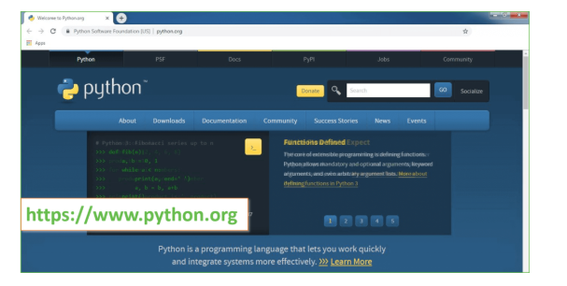
Now, check for the latest and the correct version for your operating system.
Step 2: Click on the Download Tab.
Step 3: You can either select the Download Python for windows 3.10.11 button in Yellow Color or you can scroll further down and click on download with respective to their version. Here, we are downloading the most recent python version for windows 3.10.11
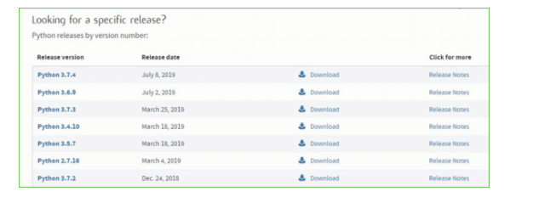
Step 4: Scroll down the page until you find the Files option.

Step 5: Here you see a different version of python along with the operating system.

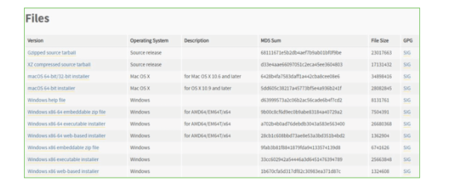

• To download Windows 32-bit python, you can select any one from the three options: Windows x86 embeddable zip file, Windows x86 executable installer or Windows x86 web-based installer.
•To download Windows 64-bit python, you can select any one from the three options: Windows x86-64 embeddable zip file, Windows x86-64 executable installer or Windows x86-64 web-based installer.
Here we will install Windows x86-64 web-based installer. Here your first part regarding which version of python is to be downloaded is completed. Now we move ahead with the second part in installing python i.e. Installation
Note: To know the changes or updates that are made in the version you can click on the Release Note Option.

Installation of Python
Step 1: Go to Download and Open the downloaded python version to carry out the installation process.
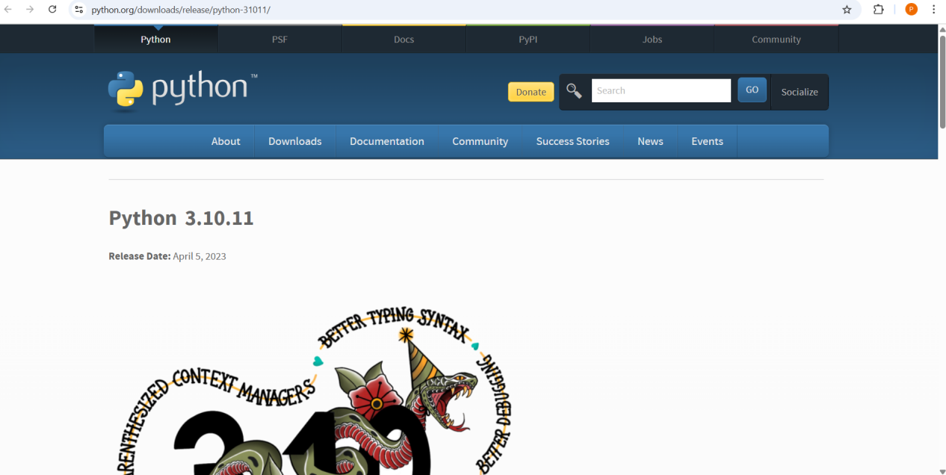

Step 2: Before you click on Install Now, Make sure to put a tick on Add Python 3.10.11 to PATH.

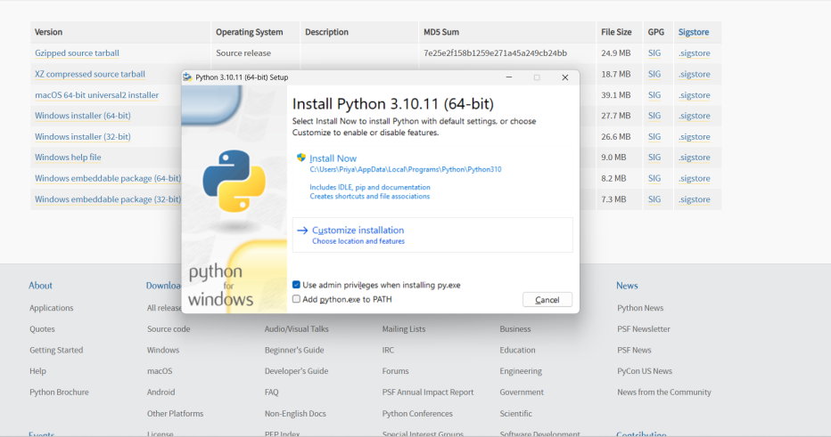
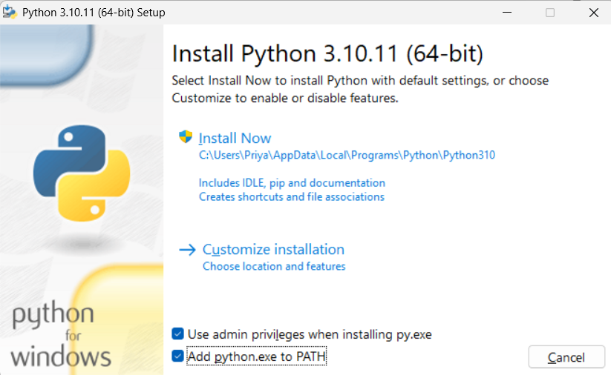
Step 3: Click on Install NOW After the installation is successful. Click on Close.

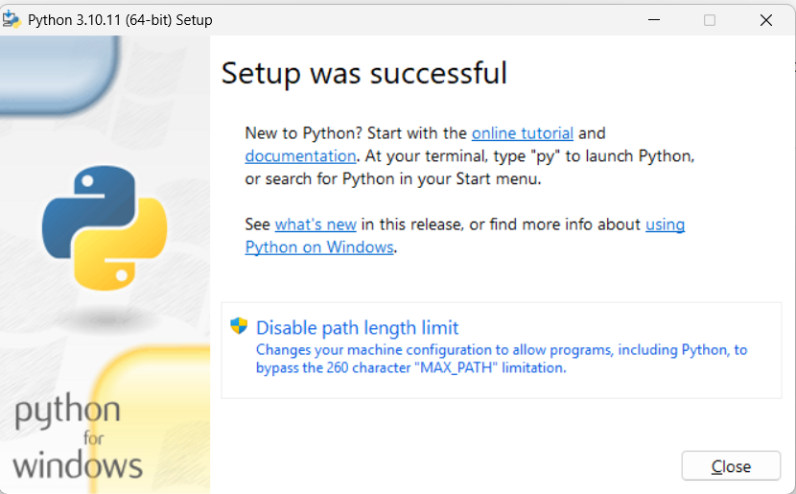

With these above three steps on python installation, you have successfully and correctly installed Python. Now is the time to verify the installation.
Note: The installation process might take a couple of minutes.

Verify the Python Installation
Step 1: Click on Start
Step 2: In the Windows Run Command, type “cmd”.

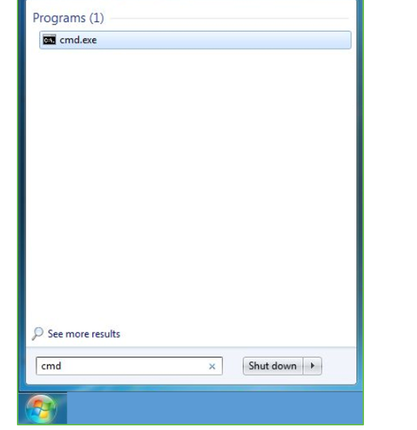
Step 3: Open the Command prompt option.
Step 4: Let us test whether the python is correctly installed. Type python –V and press Enter.

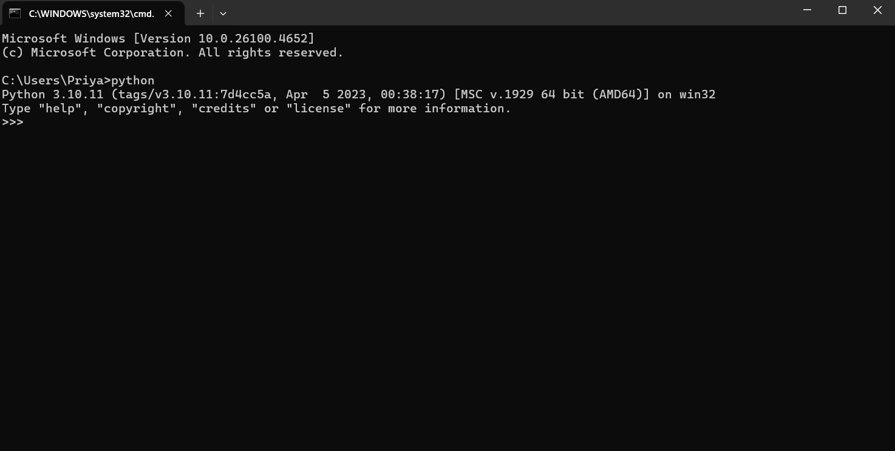
Step 5: You will get the answer as 3.10.11
Note: If you have any of the earlier versions of Python already installed. You must first uninstall the earlier version and then install the new one.

SOURCE CODE:

from django.shortcuts import render, redirect
from django.contrib.auth.models import User
from django.contrib import messages
from django.contrib.auth import login, logout, authenticate
from django.core.files.storage import default_storage

import os
import joblib
import numpy as np
import pandas as pd
import matplotlib.pyplot as plt
import seaborn as sns

from sklearn.preprocessing import LabelEncoder
from sklearn.model_selection import train_test_split
from sklearn.metrics import (
accuracy_score, precision_score, recall_score,
f1_score, confusion_matrix, classification_report
)
from sklearn.tree import DecisionTreeClassifier
from sklearn.svm import SVC
from tensorflow.keras.models import Sequential, load_model
from tensorflow.keras.layers import Dense, Dropout
from tensorflow.keras.callbacks import EarlyStopping

# ==========================
# GLOBAL VARIABLES
# ==========================
df = None
x_train = x_test = y_train = y_test = None
labels = ['Normal', 'Fraud']

# Metrics storage
accuracy, precision, recall, fscore = [], [], [], []

# ==========================
# BASIC VIEWS
# ==========================
def home(request):
return render(request, 'Home.html')

def about(request):
return render(request, 'about.html')

# ==========================
# AUTHENTICATION
# ==========================
def register(request):
if request.method == 'POST':
First_Name = request.POST['name']
Email = request.POST['email']
username = request.POST['username']
password = request.POST['password']
confirmation_password = request.POST['cnfm_password']
role = request.POST['role']

if password != confirmation_password:
messages.error(request, 'Passwords do not match.')
return render(request, 'register.html')

if User.objects.filter(username=username).exists():
messages.error(request, 'Username already exists.')
return redirect('register')

if User.objects.filter(email=Email).exists():
messages.error(request, 'Email already exists.')
return redirect('register')

# Avoid giving admin rights via registration form
user = User.objects.create_user(
username=username,
password=password,
email=Email,
first_name=First_Name,
is_staff=False
)
user.save()
return redirect('login')

return render(request, 'register.html')

def login_view(request):
if request.method == "POST":
username = request.POST.get('username')
password = request.POST.get('password')

user = authenticate(username=username, password=password)
if user:
login(request, user)
messages.success(request, 'Login successful')
return redirect('/')
else:
messages.error(request, 'Invalid username or password')
return redirect('login')

return render(request, 'login.html')

def logout_view(request):
logout(request)
return redirect('login')

# ==========================
# DATA UPLOAD & SPLIT
# ==========================
def Upload_data(request):
global df
if request.method == 'POST' and request.FILES.get('file'):
uploaded_file = request.FILES['file']
file_path = default_storage.save(uploaded_file.name, uploaded_file)

df = pd.read_csv(default_storage.path(file_path), low_memory=False)
default_storage.delete(file_path)

# Clean dataset
missing_count = df.isnull().sum().sum()
duplicate_count = df.duplicated().sum()
df = df.dropna().drop_duplicates()

# Encode categorical columns
le = LabelEncoder()
for col in df.select_dtypes(include=["object"]).columns:
df[col] = le.fit_transform(df[col])

return render(request, 'prediction.html', {
'predict': df.head(100).to_html(classes='table table-striped'),
'missing': missing_count,
'duplicates': duplicate_count
})
return render(request, 'prediction.html', {'upload': True})

def Split_data(request):
global df, x_train, x_test, y_train, y_test
if df is not None:
X = df.iloc[:, :-1]
y = df.iloc[:, -1]
x_train, x_test, y_train, y_test = train_test_split(
X, y, test_size=0.20, random_state=42
)
return render(request, 'prediction.html', {
'split': x_train.head(10).to_html(classes='table table-striped'),
'train_shape': x_train.shape,
'test_shape': x_test.shape
})
return render(request, 'prediction.html', {'error': 'No dataset uploaded yet'})

# ==========================
# METRICS
# ==========================
def calculateMetrics(algorithm, y_true, y_pred):
global accuracy, precision, recall, fscore

p = precision_score(y_true, y_pred, average='macro') * 100
r = recall_score(y_true, y_pred, average='macro') * 100
f = f1_score(y_true, y_pred, average='macro') * 100
a = accuracy_score(y_true, y_pred) * 100

accuracy.append(a)
precision.append(p)
recall.append(r)
fscore.append(f)

# Save confusion matrix plot
conf_matrix = confusion_matrix(y_true, y_pred)
plt.figure(figsize=(5, 5))
sns.heatmap(conf_matrix, xticklabels=labels, yticklabels=labels, annot=True, cmap="Blues", fmt="g")
plt.title(f"{algorithm} Confusion Matrix")
plt.ylabel('True class')
plt.xlabel('Predicted class')
os.makedirs("static/images", exist_ok=True)
plt.savefig(f"static/images/{algorithm}_confusion.png")
plt.close()

# ==========================
# MODELS
# ==========================
def train_dt_view(request):
global x_train, x_test, y_train, y_test
if x_train is None or y_train is None:
return render(request, 'prediction.html', {'error': '❌ Upload and split dataset first.'})

os.makedirs("model", exist_ok=True)
model_path = "model/dt_classifier.pkl"

if os.path.exists(model_path):
model = joblib.load(model_path)
else:
model = DecisionTreeClassifier(random_state=42)
model.fit(x_train, y_train)
joblib.dump(model, model_path)

y_pred = model.predict(x_test)
calculateMetrics("DecisionTree", y_test, y_pred)

return render(request, 'prediction.html', {
'algorithm': 'Decision Tree',
'accuracy': f"{accuracy[-1]:.2f}%",
'precision': f"{precision[-1]:.2f}%",
'recall': f"{recall[-1]:.2f}%",
'fscore': f"{fscore[-1]:.2f}%"
})

## -----------------------------
# DNN (MLPClassifier) View
def train_dnn_view(request):
global x_train, x_test, y_train, y_test

if x_train is None or y_train is None:
return render(request, 'prediction.html', {
'error': '❌ Please upload and split the dataset first.'
})

# Drop non-numeric ID columns if present
drop_cols = [col for col in ['nameOrig', 'nameDest'] if col in x_train.columns]
if drop_cols:
x_train.drop(columns=drop_cols, inplace=True, errors='ignore')
x_test.drop(columns=drop_cols, inplace=True, errors='ignore')

os.makedirs("model", exist_ok=True)
model_path = "model/DNNClassifier.pkl"

# Load or Train DNN (MLPClassifier)
if os.path.exists(model_path):
model = joblib.load(model_path)
print("✅ DNN model loaded successfully.")
else:
print("❌ DNN model not found. Training new one...")
model = MLPClassifier(hidden_layer_sizes=(64, 32),
max_iter=200,
random_state=42)
model.fit(x_train, y_train)
joblib.dump(model, model_path)
print("✅ DNN model trained and saved successfully.")

# Predict & Evaluate
y_pred = model.predict(x_test)
calculateMetrics("DNN", y_test, y_pred)

return render(request, 'prediction.html', {
'algorithm': 'DNN',
'accuracy': f"{accuracy[-1]:.2f}%",
'precision': f"{precision[-1]:.2f}%",
'recall': f"{recall[-1]:.2f}%",
'fscore': f"{fscore[-1]:.2f}%"
})

# -----------------------------
# SVM View
def train_svm_view(request):
global x_train, x_test, y_train, y_test
if x_train is None or y_train is None:
return render(request, 'prediction.html', {
'error': '❌ Upload and split dataset first.'
})

# Drop non-numeric ID columns if present
drop_cols = [col for col in ['nameOrig', 'nameDest'] if col in x_train.columns]
if drop_cols:
x_train.drop(columns=drop_cols, inplace=True, errors='ignore')
x_test.drop(columns=drop_cols, inplace=True, errors='ignore')

os.makedirs("model", exist_ok=True)
model_path = "model/svm_classifier.pkl"

if os.path.exists(model_path):
model = joblib.load(model_path)
print("✅ SVM model loaded successfully.")
else:
print("❌ SVM model not found. Training new one...")
model = SVC(kernel='rbf', probability=True, random_state=42)
model.fit(x_train, y_train)
joblib.dump(model, model_path)
print("✅ SVM model trained and saved successfully.")

y_pred = model.predict(x_test)
calculateMetrics("SVM", y_test, y_pred)

return render(request, 'prediction.html', {
'algorithm': 'Support Vector Machine',
'accuracy': f"{accuracy[-1]:.2f}%",
'precision': f"{precision[-1]:.2f}%",
'recall': f"{recall[-1]:.2f}%",
'fscore': f"{fscore[-1]:.2f}%"
})

# ==========================
# PERFORMANCE SUMMARY
# ==========================
def performance_summary_view(request):
algorithm_names = ["DecisionTree", "DNN", "SVM"]
if len(accuracy) < len(algorithm_names):
return render(request, 'prediction.html', {'error': '❌ Not all models have been evaluated yet.'})

df_metrics = pd.DataFrame({
"Algorithm": algorithm_names,
"Precision": precision,
"Recall": recall,
"F1 Score": fscore,
"Accuracy": accuracy
})

static_images_dir = os.path.join('static', 'images')
os.makedirs(static_images_dir, exist_ok=True)

chart_path = os.path.join(static_images_dir, 'performance_chart.png')
pie_path = os.path.join(static_images_dir, 'accuracy_pie.png')

# Bar charts
fig, axs = plt.subplots(2, 2, figsize=(10, 10))
fig.suptitle("Performance Metrics", fontsize=16)

axs[0, 0].bar(df_metrics["Algorithm"], df_metrics["Precision"], color='skyblue')
axs[0, 0].set_title("Precision")

axs[0, 1].bar(df_metrics["Algorithm"], df_metrics["Recall"], color='orange')
axs[0, 1].set_title("Recall")

axs[1, 0].bar(df_metrics["Algorithm"], df_metrics["F1 Score"], color='green')
axs[1, 0].set_title("F1 Score")

axs[1, 1].bar(df_metrics["Algorithm"], df_metrics["Accuracy"], color='purple')
axs[1, 1].set_title("Accuracy")

plt.tight_layout(rect=[0, 0.03, 1, 0.95])
plt.savefig(chart_path)
plt.close()

# Pie chart
plt.figure(figsize=(6, 6))
plt.pie(df_metrics["Accuracy"], labels=df_metrics["Algorithm"], autopct='%1.1f%%', startangle=140)
plt.title("Accuracy Distribution")
plt.savefig(pie_path)
plt.close()

return render(request, 'prediction.html', {
'table': df_metrics.to_html(classes='table table-bordered table-hover', index=False),
'chart_url': '/static/images/performance_chart.png',
'pie_url': '/static/images/accuracy_pie.png'
})

# ==========================
# PREDICTION WITH MLP/XGB
# ==========================
def predict_mlp_view(request):
if request.method == 'POST' and request.FILES.get('file'):
uploaded_file = request.FILES['file']
file_path = default_storage.save(uploaded_file.name, uploaded_file)
test = pd.read_csv(default_storage.path(file_path))
default_storage.delete(file_path)

test.columns = test.columns.str.strip()

model_path = 'model/DNNClassifier.pkl'
if not os.path.exists(model_path):
return render(request, 'prediction.html', {
'error': '❌ Trained MLP model not found. Please train the model first.'
})

mlp_model = joblib.load(model_path)
test_features = test.reindex(columns=mlp_model.feature_names_in_, fill_value=0)
pred = mlp_model.predict(test_features)

label_map = {0: "Normal", 1: "Fraud"}
test['prediction'] = pred
test['predicted_labels'] = pd.Series(pred).map(label_map)

return render(request, 'prediction.html', {
'predict': test.head(100).to_html(classes='table table-bordered', index=False)
})

return render(request, 'prediction.html', {'test': True})

Conclusion
The proposed suspicious financial transaction detection system successfully integrates machine learning algorithms with a user-friendly Django framework to provide an efficient and accurate fraud detection solution. By preprocessing uploaded datasets, training multiple models such as Decision Tree, DNN/MLP, and SVM, and evaluating them through key performance metrics, the system ensures a comprehensive analysis of transaction patterns. The inclusion of visualization modules, confusion matrices, and performance summaries enables users to clearly understand model behavior and select the most reliable classifier. Additionally, the real-time prediction module allows the system to classify new transaction data effectively, supporting proactive fraud mitigation. Overall, this system strengthens financial security by offering a scalable, automated, and data-driven framework capable of detecting both simple and complex fraudulent activities with improved precision and reliability.

References
- Aggarwal, C. C. (2017). Outlier Analysis. Springer.
- Bolton, R. J., & Hand, D. J. (2002). Statistical fraud detection: A review. Statistical Science, 17(3), 235–255.
- Dua, D., & Graff, C. (2019). UCI Machine Learning Repository. University of California, Irvine.
- Goldstein, M., & Uchida, S. (2016). A comparative evaluation of unsupervised anomaly detection algorithms for multivariate data. PLOS ONE, 11(4).
- Goodfellow, I., Bengio, Y., & Courville, A. (2016). Deep Learning. MIT Press.
- Han, J., Kamber, M., & Pei, J. (2012). Data Mining: Concepts and Techniques. Morgan Kaufmann.
- Mohammed, M., Badr, A., & Li, X. (2016). Machine Learning: Algorithms and Applications. CRC Press.
- Ngai, E., Hu, Y., Wong, Y., Chen, Y., & Sun, X. (2011). The application of data mining techniques in financial fraud detection: A classification framework and literature review. Decision Support Systems, 50(3), 559–569.
- Vapnik, V. (1999). The Nature of Statistical Learning Theory. Springer.
- Zhang, Y., Jiang, J., & Li, Y. (2018). A novel anomaly detection model for financial transactions using machine learning. International Journal of Computer Applications, 181(47), 1–7.

